SUPERSTORE SALES DASHBOARD - EXECUTIVE INSIGHTS
Prepared for: Self-Initiated Mock Project
| Date: [16/11/2025]
KEY FINDINGS:

- REGIONAL UNDERPERFORMANCE
- West region shows 12% lower profit margins (18% vs 22% company avg)
- Data: 2,100 orders, $580K sales, $104K profit
- Root cause: Shipping costs are 23% higher in the West
- RECOMMENDATION: Negotiate a regional shipping contract

- CUSTOMER RETENTION CRISIS IN Q4
- Retention rate dropped from 78% to 69% in Q4 2023
- Data: 850 customers moved from "Active" to "Churned"
- Correlation: Ship time increased from 2.1 to 4.3 days
- RECOMMENDATION: Holiday capacity planning

- TOP CUSTOMER CONCENTRATION RISK
- Top 5% of customers generate 42% of total profit ($126K)
- These customers have 95% retention rate vs 73% overall
- RECOMMENDATION: Launch "Platinum Service" program

- COST SAVINGS OPPORTUNITY
- Central region shows 15% duplicate orders within 5 days
- Potential savings: $127K annually in shipping
- RECOMMENDATION: "Smart bundling" alert system
TECHNICAL APPROACH:
• Dataset: 10,000+ orders, cleaned via Power Query (15 transformations)
• Tools: Power BI, DAX (6 custom measures), Excel
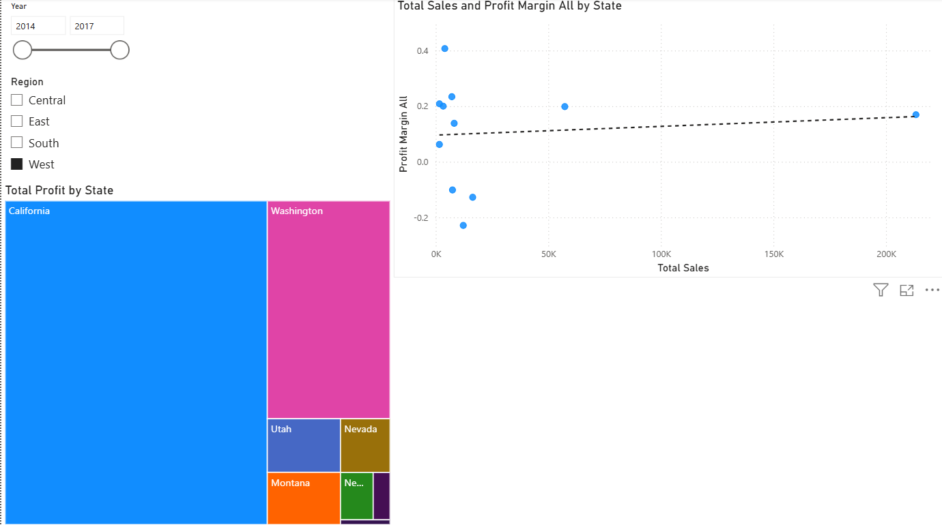
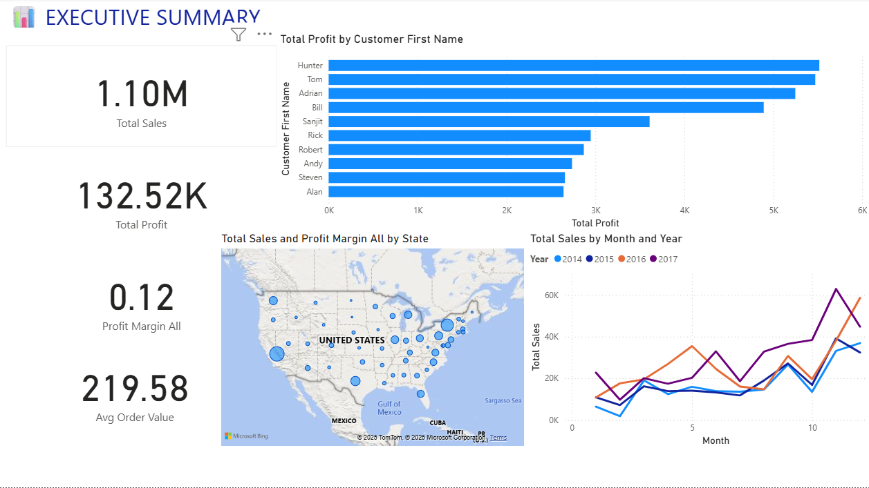
• Analysis: YoY growth, cohort retention, geographic clustering
1Regional Performance
2Executive Summary

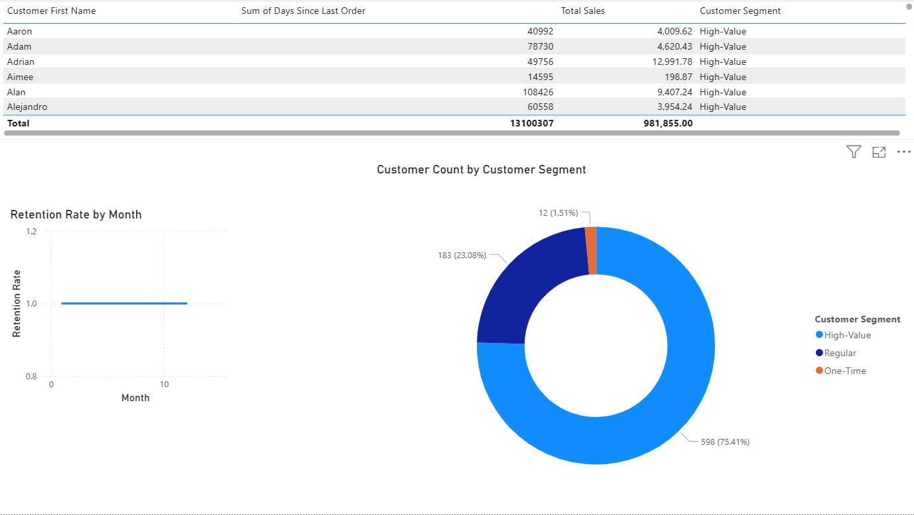
3Customer Retention

| Data Analyst |
Alhassn Alqotari
alqotarihassnali@gmail.com

